Worksheet
Class Name

The path of the sun in seasons.
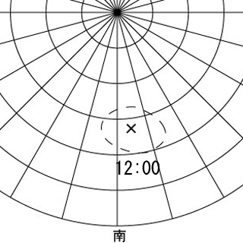
Watch the movie, note the position of the sun at each hour interval and plot it on your worksheet.
Circle and cross the centre of it as the image.

Date
What You Understood
